**Exercise No: 2**

**Date:**

**Aim:**

We aim to find the number of occurrences of a given number from the given array of numbers.

**Program:**

def countX(list,s):

c = 0

for i in range(0,len(list)):

if(list[i] == s):

c += 1

print("\n")

print(c)

list = []

x = int(input("enter the array size: "))

for i in range(0,x):

list.append(int(input()))

s = int(input("enter the number to find: "))

countX(list,s)

**Link:**

http://103.53.53.18/mod/vpl/forms/edit.php?id=230&userid=1806

**Output:**

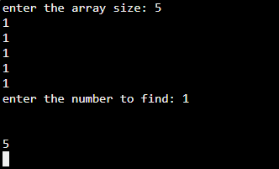

**Result:**

The output has been successfully executed and verified.